Daily Graphic PSA Objectives
By the end of the period I will demonstrate my ability to communicate and work with group members by selecting a PSA topic, discussing graphic novel style strategies for designing a panel, and sketching out these ideas.
By the end of the period I will demonstrate my mastery of photography and my plan for photographing our PSA by successfully shooting all the required shots.
By the end of the period I will have demonstrated my understanding of critically analyzing photographs for their technical quality and ability to tell my story.

By the end of the period I will understand several Photoshop techniques for creating a comic effect and demonstrate my understanding by successfully converting two imaging into comic style graphics.
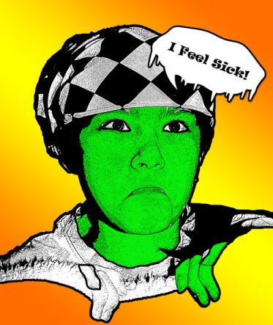
By the end of the period you will demonstrate your understanding of the Photoshop comic techniques by editing your photos into your PSA.

By the end of the period I will demonstrate my mastery of photography by successfully shooting any required pick-up shots.

By the end of the period I will demonstrate my mastery of Photoshop comic techniques by successfully making all the changes recommended by the class to improve my PSA.

